Minnesota Encounter Alert Service

Patient Information Service Query Use Case

Version: 2

Date: November 17, 2020

Use Case: Patient Information Service Query
Version | Approval Date
2.0 | November 17, 2020

Overview
While EAS is generally thought of as a “PUSH” model for sending alerts, it is possible to provide “in-context” alerts, via a “PULL” or query model, where alert information is seamlessly shown within the provider’s workflow. Implementation examples of a query model for in-context alerts includes FHIR-based API apps (such as EPIC’s App Orchard) or the national networks (such as eHealth Exchange). Both of these implementation query examples can be supported by EAS when serving as a “Patient Information Service” (PIS) or “Record Location Service” (RLS). Further, MN EAS could initiate or respond to a “panel check” query, to enable EAS or another HIO to confirm an active patient subscription before sending an ADT, and to enable reciprocity between MN EAS as a MN HDI and HIO’s as described in the MN HIE Oversight statute.

Permitted Purposes
In addition to EAS and eHealth Exchange DURSA permitted purpose limitations, the EAS Patient Information Service query responses would assume to be further limited in three dimensions:
#1: Providers: EAS would assure that the user or organization querying must attest that they meet all conditions of the MHRA related to making a query of a PIS/RLS (including the appropriate consent & NPP). Health Plans and MDH are not allowed to query the PIS/RLS.
#2: Patients on Panels: EAS would only return a query response if the patient is on an active EAS panel (and therefore has opted-in).
#3: Patient Consent: EAS would only return a query response if the patient has also not opted-out of the PIS.
Note that this use case does not add any additional requirements on the EAS data sources.
PIS and Consent is described here: https://www.revisor.mn.gov/statutes/cite/144.293

Use Case Description
Responding to Queries: The EAS Patient Information Service (EAS PIS), when queried by an authorized query initiator, will match to the patient demographics in the EAS MPI, confirm the patient is on an active patient panel, confirm that the patient has not opted-out. The EAS PIS, if there is a successful match, will return the demographics and active subscriber(s). This query response could also include other panel attributes such as the patient’s care team and the care teams contact information (to aid care coordination).
Initiating Queries: The MN EAS could initiate a patient discovery query of another node on the national networks (eHealth Exchange, for example), and if there’s one and only one match, forward an ADT message to the responding node. This assumes patient consent is verified (either by MN EAS before making the query (from the ADT or panel), or if the responding node’s response includes filtering for consenting patients.

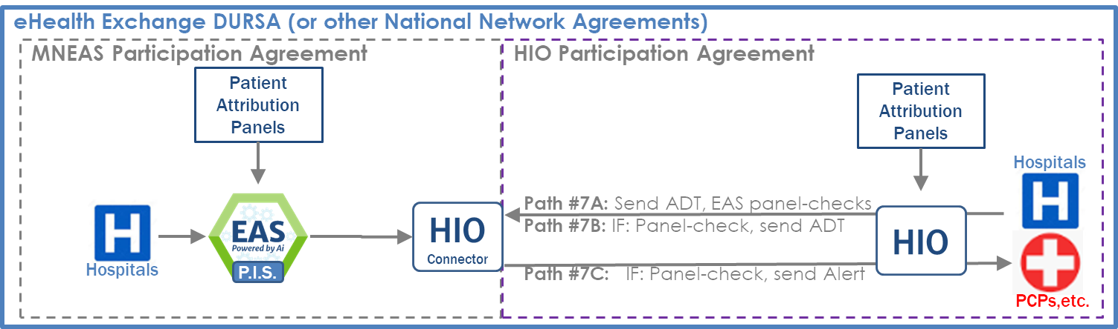

https://www.revisor.mn.gov/statutes/cite/62J.4981
https://www.revisor.mn.gov/statutes/cite/144.293#stat.144.293.8

