Notice of Admission Use Case

Use Case: Notice of Admission (NOA)
Version | Approval Date
1.0 | 17Nov2020

Overview
Most health plans require hospitals to furnish a “Notice of Admission” (NOA) for their members (especially for Medicaid MCO’s and other risk-sharing lines of business). Given the “ONC Information Blocking” regulation, and the assumption that Health Plans may be Participants in MN EAS, this use case provides the details regarding MN EAS interactions with Health Plans.

Permitted Purposes
The permitted purposes are Treatment, Payment or Operations as permitted by Applicable Law.

Use Case Description
The NOA use case is depicted below as “Path 5” of the MN EAS alerting flows. Specifically, if a Health Plan is a MN EAS Participant, and submits a member patient panel to MN EAS, similar to other alerts, MN EAS will send an alert to a health plan if there’s a panel match (and with the appropriate consent).
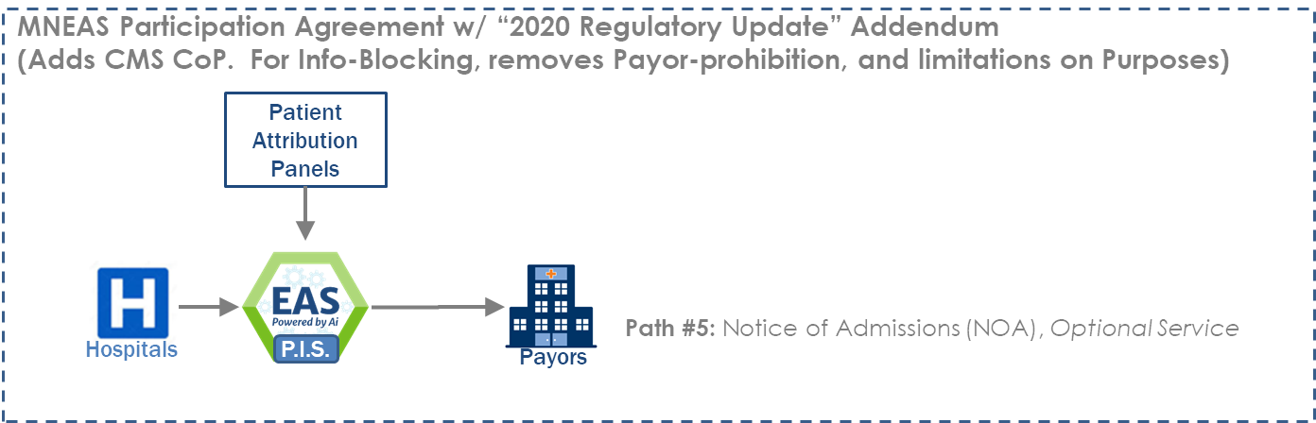

Section 4004 of the 21st Century Cures Act added a new Section 3002 to the Public Health Service Act, 42 U.S.C. 300jj-52, which was further implemented by the HHS ONC Final Rule codified as 45 C.F.R. Part 171, to prohibit certain “information blocking” practices that are “likely to interfere with access, exchange, or use of electronic health information”.

